CHAPTER 18 SUMMARY AND KEY CONCEPTS

18.1 Voter Participation and Costs of Elections
The theory of rational ignorance says voters will recognize that their single vote is extremely unlikely to influence the outcome of an election. As a consequence, they will choose to remain uninformed about issues and not vote. This theory helps explain why voter turnout is so low in the United States.

18.2 Special Interest Politics
Special interest politics arises when a relatively small group, called a special interest group, each of whose members has a large interest in a political outcome, devotes considerable time and energy to lobbying for the group’s preferred choice. Meanwhile, the large majority, each of whose members has only a small interest in this issue, pays no attention.
We define pork--barrel spending as legislation whose benefits are concentrated on a single district while the costs are spread widely over the country. Logrolling refers to a situation in which two or more legislators agree to vote for each other’s legislation, which can then encourage pork-barrel spending in many districts.

18.3 Flaws in the Democratic System of Government
Majority votes can run into difficulties when more than two choices exist. A voting cycle occurs when, in a situation with at least three choices, choice A is preferred by a majority vote to choice B, choice B is preferred by a majority vote to choice C, and choice C is preferred by a majority vote to choice A. In such a situation, it is impossible to identify what the majority prefers. Another difficulty arises when the vote is so divided that no choice receives a majority.
A practical approach to microeconomic policy will need to take a realistic view of the specific strengths and weaknesses of markets as well as government, rather than making the easy but wrong assumption that either the market or government is always beneficial or always harmful.

CHAPTER 19 SUMMARY AND KEY CONCEPTS

19.1 Absolute and Comparative Advantage
A country has an absolute advantage in those products in which it has a productivity edge over other countries; it takes fewer resources to produce a product. A country has a comparative advantage when it can produce a good at a lower cost in terms of other goods. Countries that specialize based on comparative advantage gain from trade.

19.2 What Happens When a Country Has an Absolute Advantage in All Goods
Even when a country has high levels of productivity in all goods, it can still benefit from trade. Gains from trade come about as a result of comparative advantage. By specializing in a good that it gives up the least to produce, a country can produce more and offer that additional output for sale. If other countries specialize in the area of their comparative advantage as well and trade, the highly productive country is able to benefit from a lower opportunity cost of production in other countries.

19.3 Intra-industry Trade between Similar Economies
A large share of global trade happens between high-income economies that are quite similar in having well-educated workers and advanced technology. These countries practice intra-industry trade, in which they import and export the same products at the same time, like cars, machinery, and computers. In the case of intra-industry trade between economies with similar income levels, the gains from trade come from specialized learning in very particular tasks and from economies of scale. Splitting up the value chain means that several stages of producing a good take place in different countries around the world.

19.4 The Benefits of Reducing Barriers to International Trade
Tariffs are placed on imported goods as a way of protecting sensitive industries, for humanitarian reasons, and for protection against dumping. Traditionally, tariffs were used as a political tool to protect certain vested economic, social, and cultural interests. The WTO has been, and continues to be, a way for nations to meet and negotiate in order to reduce barriers to trade. The gains of international trade are very large, especially for smaller countries, but are beneficial to all.

Exhibit 5
U.S. Balance of Payments, 2015 (In Billions of Dollars)
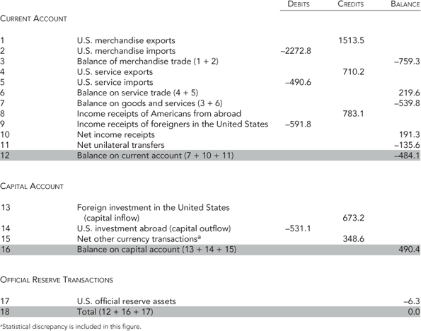
Source: http://www.bea.gov.

